**In Class Activity- Class 2**

Chapter 1, pp. 1-6

* On Canvas, find the file “JASPclass2.csv” and download to your computer.
* Then open JASP. Click “open a data file” and select the JASPclass2.csv.
* The data in this file are from 11 young adults (note: this is not real data). They were asked the following five questions:

1) What is your gender identity?

2) What is your age?

3) If you had to rank your favorite 5 courses for this semester (1= favorite, 5=least favorite), where in the ranking would this class fall?

4) What was your grade on the final exam?

5) On a scale of 1 to 7 (1 = not at all, 7 = very much), how much did you like this class?

1) There are five variables from these data. Fill out the following chart:

|  |  |  |  |  |
| --- | --- | --- | --- | --- |
| **Variable Name (in JASP)** | **Range of Values** | **Level of Measurement**  **(scale, ordinal, nominal)** | **Discrete or continuous?** | **Participant #4’s score** |
| Gender | Male, female, nonbinary | nominal | discrete | female |
| Age | 18-34 | scale | continuous | 19 |
| Favorite | 1-5 | ordinal | discrete | 2 |
| Grade | 0-100 | scale | Continuous | 94 |
| Like | 1-7 | ordinal | discrete | 7 |

2) In JASP, each variable name has a colorful icon next to it. Click the icon. What does it represent?

Each of the icons represent whether the variable is nominal, ordinal, or scale.

2b) Does each symbol accurately reflect the variable? If not, change the icon(s) so that they are correct. Then take a screen shot (on mac: command shift 4) of the variable icons and paste it in this document.

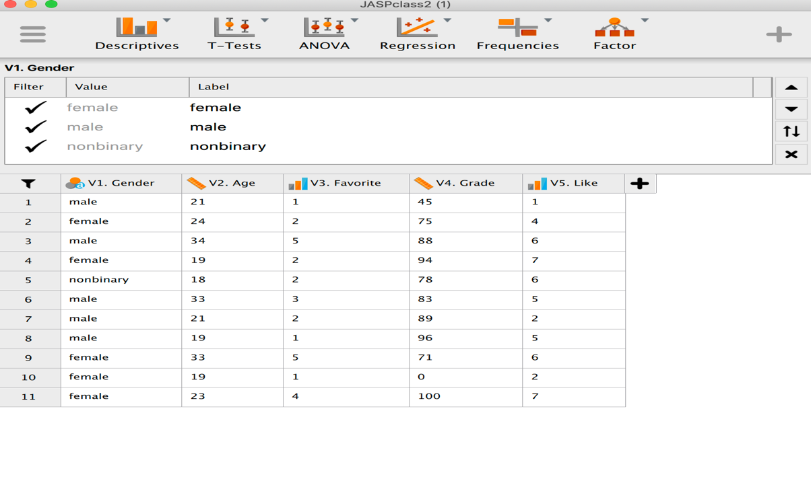

*Good job! Now you know how to open a data file in JASP and assign the level of measurement. JASP makes its best guess for you when assigning level of measurement, but they aren’t always right! Always make sure you check and fix them on your own.*

3) Lastly, open the data file in Excel. (hint: this is a .csv file) Do the data look the same? If you filled out the table above again, would all the answers be exactly the same? (hint: the answer is no! What is the main difference? How could we fix this so it wouldn’t be an issue switching between JASP and Excel?)

No, because when you we open the data in excel the participant numbers start at 2 not 1. In order to prevent this they can color code each participant so that they know what data belongs where.